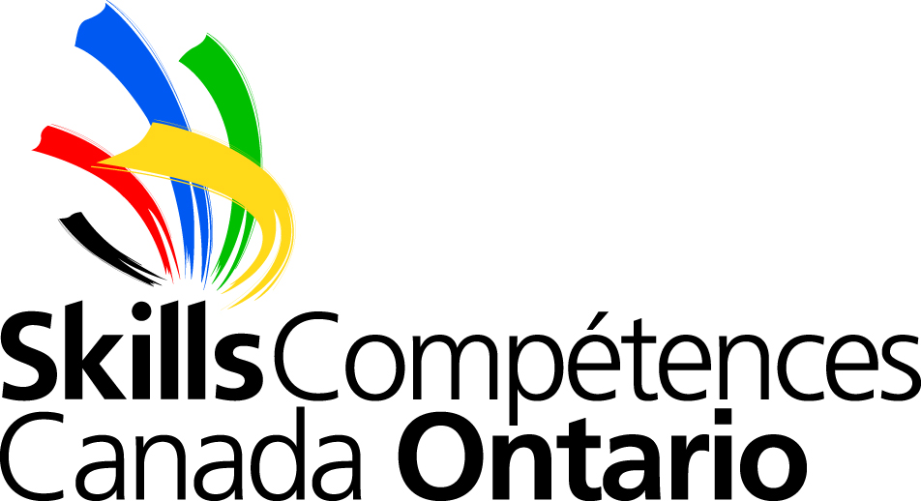

Skills Ontario Summer Camps
Exploring Careers in Skilled Trades and Technologies One Hands-on Activity at a Time

Weekly Agenda Overview
Georgian College, Owen Sound
July 18-22, 2022
Homeroom: Room F214
Drop-Off Location: 1450 8th Street East Owen Sound, ON N4K 5R4 – Main Entrance

*** Activities may be subject to change***
- Monday | - Activity: Towering News  - Workshop: Culinary
- Tuesday | - Activity: Bleach T-shirts  - Activity: Welding (Please being a long sleeve/hoodie)
- Wednesday | - Activity: Kite Building  - Workshop: Electrical  - Activity: Pop Bottle Rockets
- Thursday | - Activity: Roller Coasters  - Activity: Egg Drop  - Workshop: Carpentry  - Activity: Cup Stack
- Friday | - Activity: Squishy Circuits  - Activity: Tin Foil Boats  - Parent Showcase: all parents are welcome; commences at 3:00 pm. Parking is free, please park in lot 1.
- Tips | - Remember to wear closed-toe shoes every day. All workshops require long pants without rips, no loose clothing or strapless shirts, and long hair to be tied back.  - Be sure to bring extra water or juice when the weather is hot. Camp begins at 9:00 and concludes at 4:00 each day. Additional supervision will not be available.
- Staff | - Katie Cameron: 705-257-5143P  - Judhis Lilly: 416-702-3486

