2022 Dick Hopkins Award of Excellence in
Technological Education
Nominations are due: March 31, 2022
In a technological world, there is nothing more important than ensuring the next generation is well prepared to survive and thrive into the future. This requires dedicated, enthusiastic, and motivated technology teachers. It requires teachers who care, teachers who can inspire students, and excel in teaching technology.  Dick Hopkins exemplified such a teacher. Dick Hopkins, a  technology educator at Napanee and Sydenham high schools and Queen’s University Faculty of Education, exemplified the energy and enthusiasm of a great technology educator who inspired a generation of teachers and students.  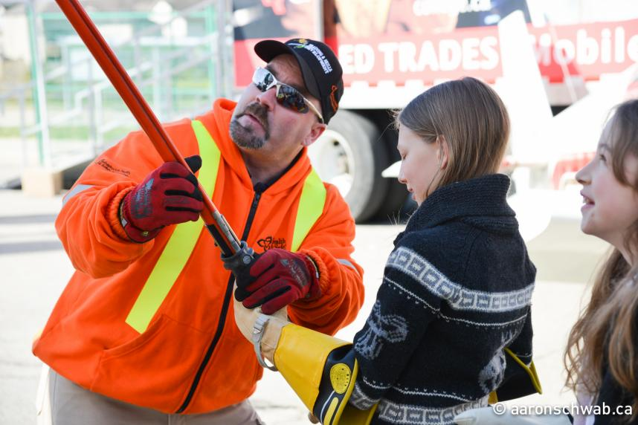  A hard-working technology educator, Dick continually asked his students to push the envelope to do great things. Dick was a champion of the community-based project, like the motorized bed for bedridden patients at the local hospital. Dick was also a champion of skills competitions, encouraging his students to challenge themselves, to showcase their talents to the community, and to the world. He vigorously promoted the skilled trades as career choices for his students. At Queen’s University, Dick was an admired master teacher, inspiring a generation of new technology teachers who are now working all over the province. | Dick passed away suddenly in October 2002. In honour and remembrance of our friend and colleague, the Ontario Council for Technology Education (OCTE) and Skills Canada - Ontario have initiated an annual award of excellence for an outstanding technological educator in Dick’s name. This award will be presented annually at the Skills Canada - Ontario Provincial Competition, in recognition of Dick’s active participation and promotion of skills competitions and events.  This award will recognize excellence in technological education and will inspire others to do great things.  If you know a great technology educator from Grades 1 to 12, please send in your nomination. Recognizing the achievements of your colleagues is inspiring and very rewarding.  Congratulations to our past award winners:  2021-Al Nason – Notre Dame Catholic Secondary School  2020 - Mario Blouin – Conseil Scolaire Catholique de District Des Grandes Rivieres  2019 – Bill Fetter – Greater Essex County District School Board  2018 – Jacob Smith – Port Perry High School  2017 – Aldo Cianfrini – Ministry of Education, Education Officer, Student  Success Policy Branch  2016 – Kevin Shea – Ontario Council for Technology Education  2015 – Glenn Ellis – Ottawa Carleton District School Board  2014 – David Lewis – Halton District School Board  2013 – Paul McDonough, All Saints Catholic High School, Kanata, ON OCSB  2012 – Slawmir Dobrowolski – St. John’s College, Brant, Haldimand, Norfolk Catholic District School Board  2011 – Ray Morrison - Bluewater District School Board & Cheryl Lovell –  Greater Essex County District School Board  2010 – Randy Dyck – Waterloo Region District School Board & Dario Rossit – Greater Essex Country District School Board  2009 – David Graves – Halton District School Board & Bud Halpin – Saugeen District Secondary School  2008 – Sergio Borghesi – Niagara Catholic District School Board  2007 – Robert Darling – Brantford Collegiate Institutes  2006 – Dan Krotsch  2005 – Bob Chambers  2004 – Kevin Graham  2003 – Mike Sewell
We encourage individuals and/or organizations to nominate educators for the Dick Hopkins Award of Excellence in
Technological Education based on the following criteria:

1. Candidate must be an Ontario technological educator (Science & Technology grades 1-8, and/or Technological Education grades 9-12) or administrator involved in technological education. Nominations of qualified retired individuals are acceptable.

2. Candidate should demonstrate an exemplary educational program incorporating, but not limited to, community-based projects, promotion of skills competitions and events; and the promotion of the skilled trades and technical occupations, whether locally, regionally, provincially, or nationally.

3. Candidate should be an educator that is a member of OCTE and/or involved with Skills Canada – Ontario, as well as displaying enthusiasm for the profession of technological education and promotes quality teaching and learning, and who has inspired students and/or colleagues to go beyond the ordinary.

Please complete the nomination form below and send in the required information.

2022 Dick Hopkins Award of Excellence in
Technological Education
NOMINATION FORM

Nominator Information (Please print):
Nominator ___________________________ Relationship to Nominee__________________________________
School/Organization __________________________________________________________________________
Telephone _________________________________Fax _________________________________________________________________
Email: ____________________________________________________________________________________________________________________

Nominee Information (Please print):
Person Nominated ____________________________________________________________________________
School/ Organization _______________________School Board ________________________________________
Area of Specialty (grade taught and subject area) ___________________________________________________
Telephone ____________________________________ Fax _________________________________________________________
Email _________________________________________________________________

RATIONALIZATION / NOMINEE CONTRIBUTION

- On a separate piece of paper, in a 250-word essay, briefly outline this individual’s contribution to technological education in Ontario, giving reasons why they should receive the award. Be sure to include specific stories, events planned, initiatives and activities the nominee inspired or was involved in.
- Please include 3 letters of reference for the nominee. Letters of reference must accompany the nomination form.
- Nominations that are incomplete will not be considered.

All nominations must be received by March 31, 2022.

A committee of judges will be selected to review the nominations and decide on a winner. The decision of judges will be final. The winner will be notified prior to the skills competitions and will be invited to attend the awards presentation.
All submissions must be sent to the attention of: Annual Dick Hopkins Award of Excellence
c/o Skills Canada - Ontario

Email: gloro@skillsontario.com

