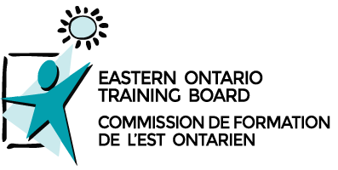

Skills Ontario Summer Camps
Exploring Careers in Skilled Trades and Technologies One Hands-on Activity at a Time

Weekly Agenda Overview
Eastern Ontario Training Board, Cornwall
July 25-29, 2022
Homeroom: Training Room
Drop-Off Location:
Main Entrance

*** Activities may be subject to change***
Camp Highlights | - Workshop: “JA Day” Business Basics  - Workshop: “Be An Entrepreneur”  - Off-site Industry Tour: Ontario Power Generation  - Off-site Industry Tour: Operating Engineers Training Institute of Ontario  - Off-Site Tour: St. Lawrence College
Important Notes | - Remember to wear closed-toe shoes every day. All workshops require long pants without rips, no loose clothing or strapless shirts, and long hair to be tied back.  - Covid tests will be conducted at camp on Thursday morning before going to Operating Engineers Training Institute of Ontario. Parents must be present until tests are completed, as anyone testing positive will not be able to participate.  - Be sure to bring extra water or juice when the weather is hot.  - Camp begins at 9:00 and concludes at 4:00 each day. Additional supervision will not be available.  - Parent Showcase: all parents are welcome; commences at 3:00 pm. Paid parking available next door in the municipal lot (do not use reserved parking).
Staff | - Angela Wilkins 905-809-2206  - Emily Collard 613-552-7797

